**Planning for my final report**

1. **Abstract**
2. **Introduction**
   1. **Motivation:** why we use surrogate model & problems statement
   2. **Background:** surrogate models and main types
3. **Methodology**
   1. **Gaussian Process Regression** 
      1. **Main Principle:** explain the principle of GPR
      2. **Kernels functions:** introduce the common-used co-variances functions
   2. **Error Analysis Methods:** RMSE and R^2
4. **Results**
   1. **Maximum Principle Stress Prediction**
      1. **7 Testing Points Methods:** 7 random points are selected as testing data, leaving the remaining 42 as training data.
      2. **Prediction in New Data:** 14 different load combination are randomly generated and the prediction of max stress is given by GPR.
      3. **Comparison between Different Kernel functions:** 3 different kernel functions (covariance functions) and their combinations are used to give the prediction for the same testing data. Their prediction accuracy are compared.
   2. **Maximum Principle Stress Position Prediction**
      1. **Train X and Y coordinates** **separately:** the x and y coordinates of max stress are trained separately.

**4.2.2 Prediction Max Stress Position in Polar Coordinate:**

max stress occurs in the inner cycle of the model. So equation (x-a)²+(y-b)²=r² should be satisfied. Therefor the training of x y coordinate can be simplified into the training of angle from reference direction(with the distance r) in polar coodinate.

**4.2.3 Prediction Max Stress Position in Polar Coordinate with 121 Training Samples:** more training samples are used and prediction accuracy are improved.

1. **Conclusion**
2. **Acknowledgment**
3. **Reference**

**New Results**

**4.1.3 Comparison between Different Kernel functions**

3 different kernel functions (covariance functions) and their combinations are used to give the prediction for the same testing data. The mean function is always empty. RMSE, R^2 error and the time to running the code are given in table 1.

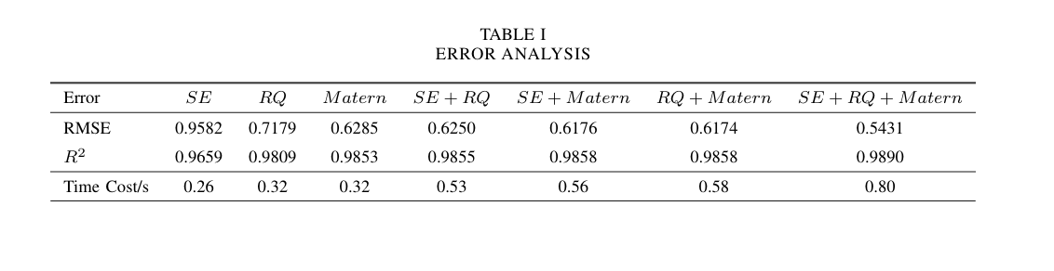

It is not hard to find that the prediction accuracy increase with more kernels combined. But it costs more time.

**4.2.1 Train X and Y coordinates** **separately:**

X and Y coordinates are first trained separately with 49 training data.

a) The fitting line of x coordinate

b) The fitting line of y coordinate

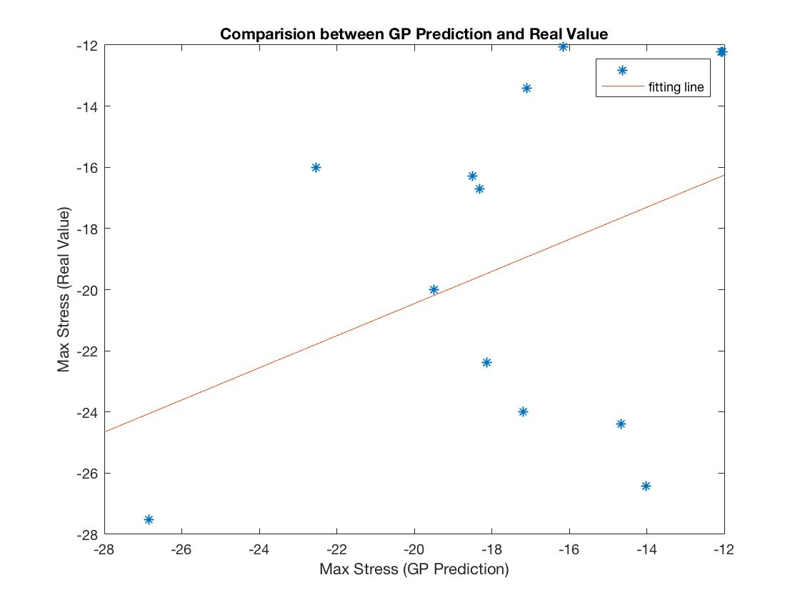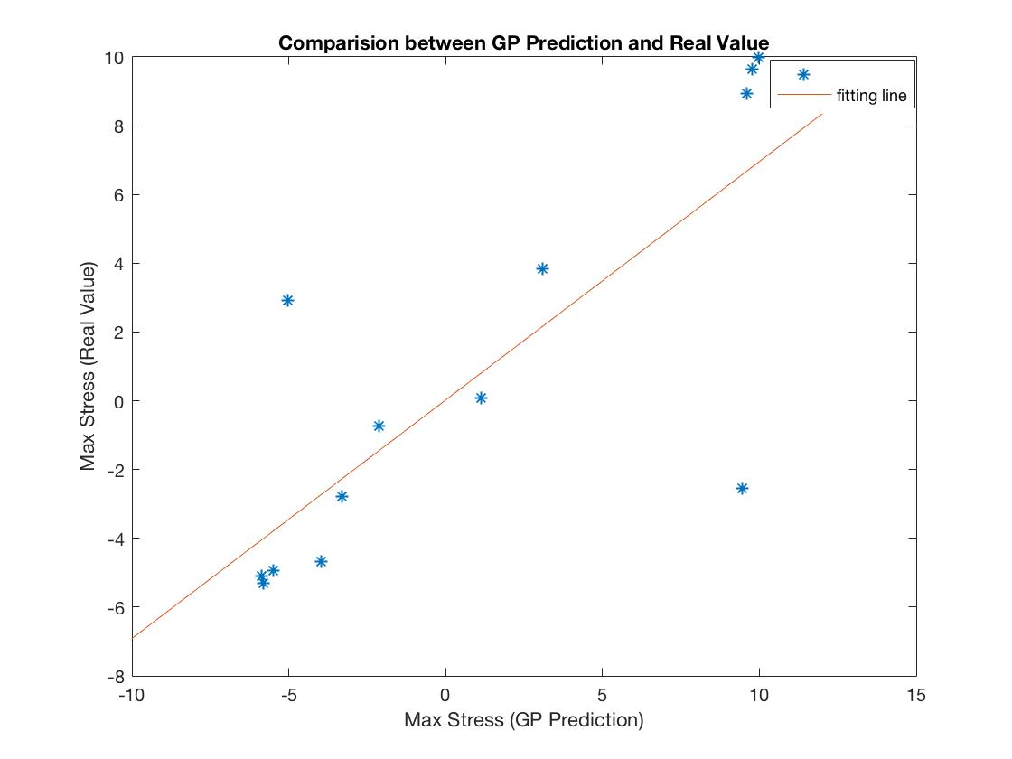

Figure 1: Fitted line of x and y coordinate training with 49 samples

RMSE of y coordination prediction is 5.1811 and for y is 3.6515.

The fitted line of x coordinate is: y=2.5x +27.8.

The fitted line of y coordinate is: y=0.93x–0.74

**4.2.2 Prediction Max Stress Position in Polar Coordinate:**

max stress occurs in the inner cycle of the model. So equation (x-a)²+(y-b)²=r² should be satisfied. Therefor the training of x y coordinate can be simplified into the training of angle from reference direction (with the distance r) in polar coordinate. Now the problems are simplified because the 2 outputs problems(x,y) becomes single output problem(angle).

**1.** I transfer coordinate of max stress from Cartesian coordinates into Polar coordinate:

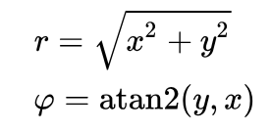

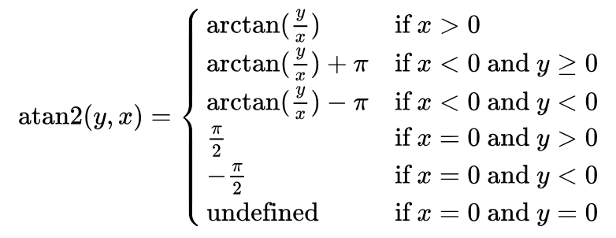

Here **r** is always the radius of inner cycle. So the angle are the only training output.

**2.**The angle are used to do the training. After training, I transfer the prediction angle into x, y coordinates:

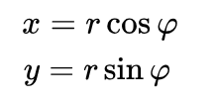

and compared with the real x-y coordinates:

a) The fitting line of x coordinate

b) The fitting line of y coordinate

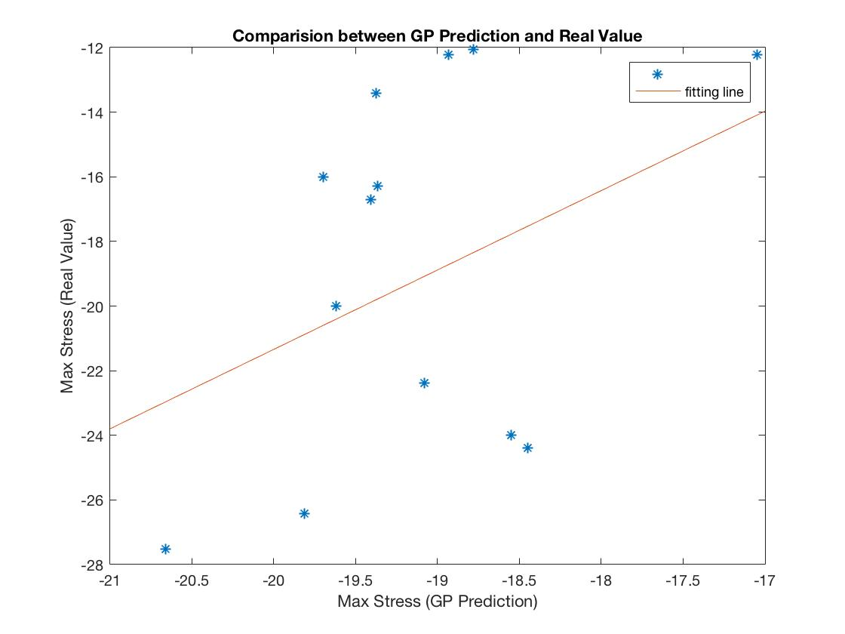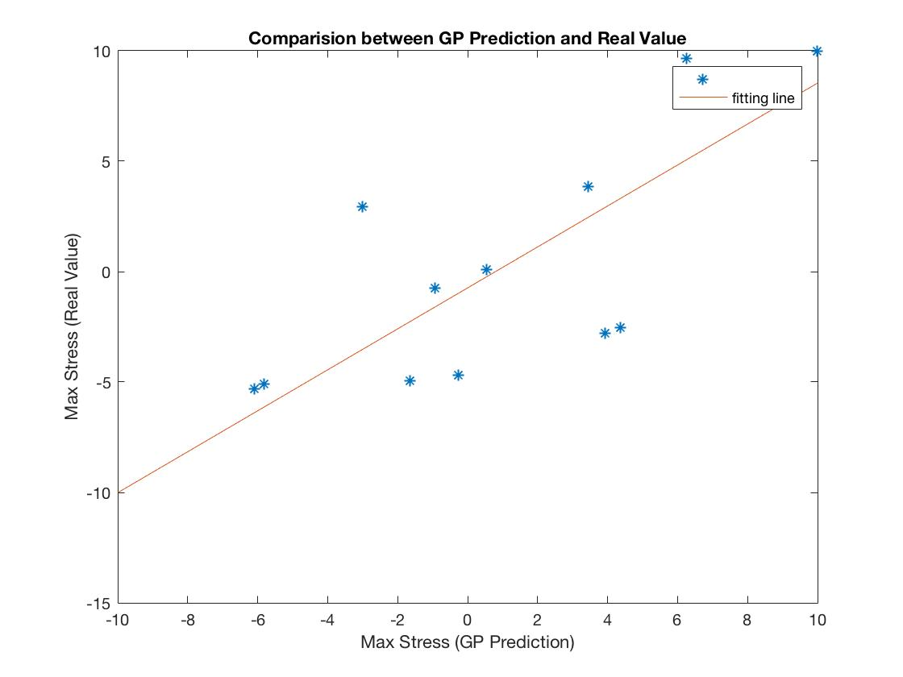

Figure 2: Fitted line of polar coordinate training with 49 samples

RMSE of y coordination prediction is 5.611 and for y is 3.905.

The fitted line of x coordinate is: y=0.53 x – 9.95.

The fitted line of y coordinate is: y=0.69x – 0.022

Although the problem is simplified into a single output problem, the prediction results have not been improved.

**4.2.3 Prediction Max Stress Position in Polar Coordinate with 121 Training Samples**

121 training samples are used and the prediction accuracy are greatly improved.

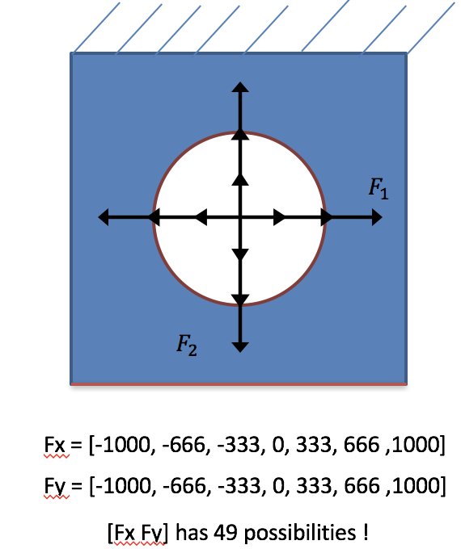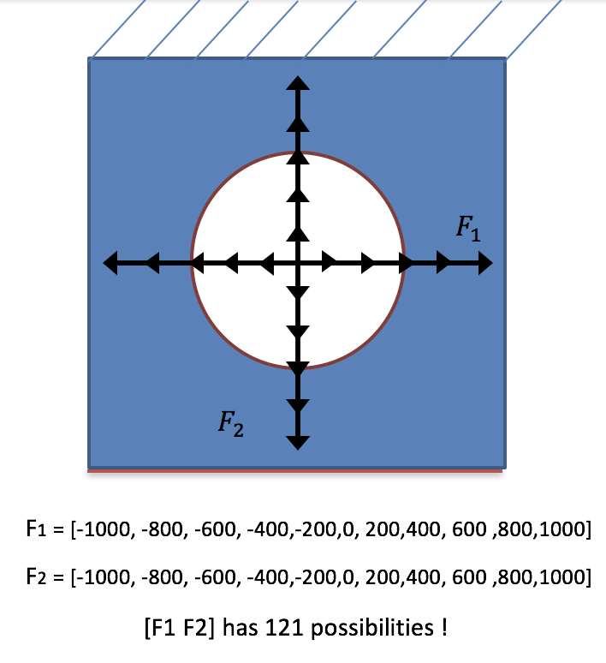

Figure 3: sampling

Figure 4: Fitted line of polar coordinate training with 121 samples

a) The fitting line of x coordinate

b) The fitting line of y coordinate

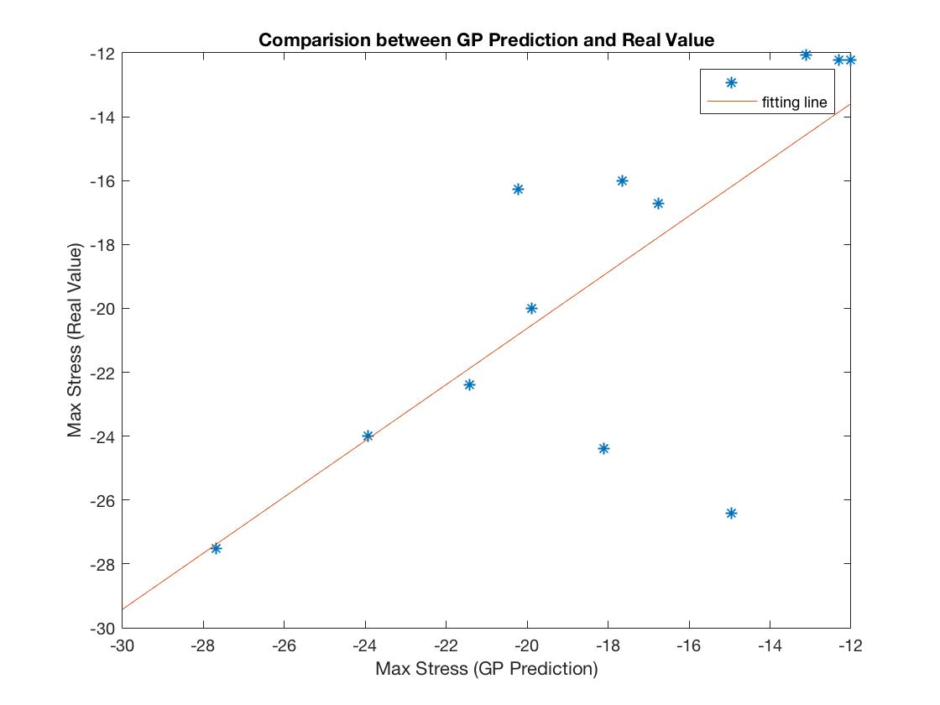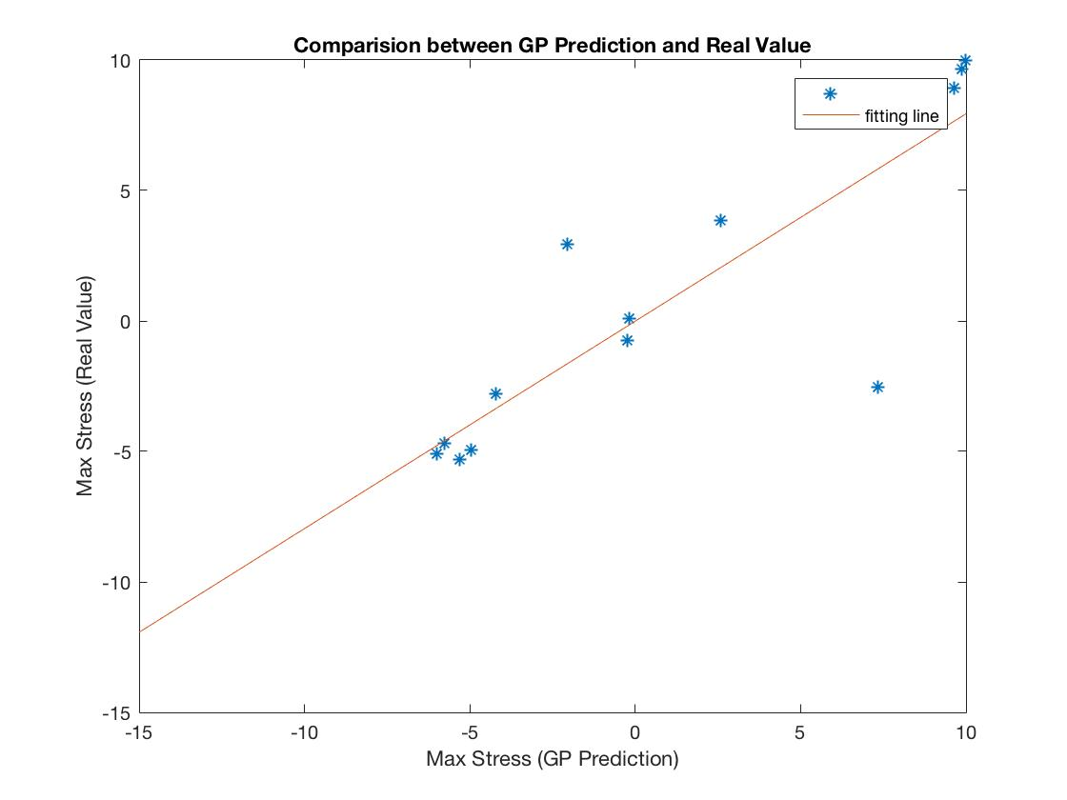

RMSE of y coordination prediction is 3.7 and for y is 3.0.

The fitted line of x coordinate is: y=0.88 x – 3.0.

The fitted line of y coordinate is: y=0.80x

**4.1.2 Prediction in New Data**

The fitted line of max stress is improved: y= 1.01x -0.41